TAMU Sketch Recognition Sketch Player Program

I. Program Description

The sketch player program allows users to visualize and hear both sketch and speech data collected using the data collection program. Users can specify whether to playback only sketch, only speech, or a combination of both. The program also allows a background image (or map) to be displayed in the background for context.

II. Loading a Sketch

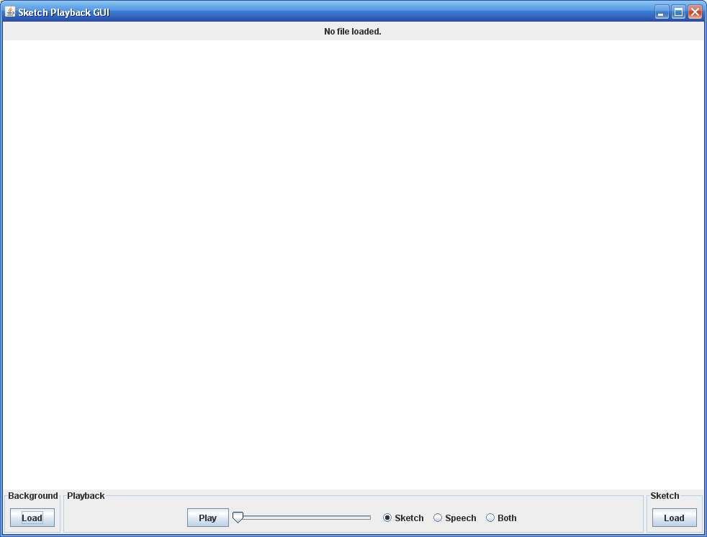

The player is composed of three section: “Background”, “Sketch”, and “Playback.”

a. Background: If the user wishes to load a background image (presumably the image that was shown at draw time) it can be loaded by clicking the “Load” button and selecting the image file from disk.

b. Sketch: To load a sketch from file, the user presses the “Load” button and selects the XML file containing the sketch data. If the sketch has an associated speech file (same name but .wav) then it will be loaded as well.

c. Playback: Once a sketch has been loaded the user can choose whether to display only the sketch animation, only the speech playback, or a combination of both using the designated radio buttons. After a mode of playback is selected the user can than press the “Play” button to begin playback. A timeline can be manipulated to rewind and fast-forward a sketch.

III. Technical Notes

Currently, sketch playback is very slow for larger size sketches (any sketch XML file greater than about 200 KB). Sketch and speech playback is also very buggy due to a combination of thread synchronization and the delay in sketch animation for larger sketches (which are typically the sketches that contain audio).

